DIGITAL DESIGN
&
COMPUTER ORGANISATION

MINI PROJECT
TITLE: SMART WATER LEVEL CONTROLLER USING FSM
TEAM MEMBERS:
- ABDUL MUHEETH K (PES1UG24CS550)
- ANIRUDH M (PES1UG24CS556)
- PRAVEEN (PES1UG25CS832)

PROBLEM STATEMENT

Project title: Smart Water Level Controller using Finite State Machine (FSM) with Verilog implementation.
Problem statement:
Design a digital controller that automatically manages a water pump to maintain tank water level using three binary level sensors (Low, Mid, High). The controller must:
- Turn the pump ON when the tank is empty or below the desired level.
- Keep the pump ON while the tank fills up until the high sensor is reached.
- Turn the pump OFF when the high level is reached to prevent overflow.
- Respond to falling water level by re-enabling the pump when necessary.
- Be implemented as a synchronous finite state machine with an asynchronous reset.
- Provide optional features: manual override, LED indicators, alarm on overflow/fault, and basic debouncing or filtering of sensor inputs.
Inputs: S0 (low/empty sensor), S1 (mid sensor), S2 (high sensor), clk, reset, (optional manual_on, manual_off).
Outputs: pump (drive to pump relay/driver), state_leds (2-bit state indicator), alarm (optional).
Performance constraints:
- Synchronous design with a single clock domain.
- Robust to contact bounce: add debouncing or simple digital filtering.
- Safe default: on reset, pump should be ON to avoid water starvation (or design choice: OFF — but this project uses ON on reset).

SOLUTION

Overview:
- States (CS1 CS0): 00 = EMPTY, 01 = HALF, 10 = FULL.
- Inputs: S0 (low), S1 (mid), S2 (high).
- Outputs: pump (1 = ON, 0 = OFF).
- Storage: two D flip-flops store CS1 (MSB) and CS0 (LSB).
- Next states (NS1 NS0): 00 = EMPTY, 01 = HALF, 10 = FULL.

Truth table:
- From EMPTY (00) state
CS1 CS2 | S2 S1 S0 | NS1 NS0 | Pump
00 | 000 | 00 | 1
00 | 001 | 00 | 1
00 | 010 | 01 | 1
00 | 011 | 01 | 1
00 | 100 | 01 | 1
00 | 101 | 01 | 1
00 | 110 | 01 | 1
00 | 111 | 01 | 1

- From HALF (00) state
CS1 CS2 | S2 S1 S0 | NS1 NS0 | Pump
01 | 000 | 00 | 1
01 | 001 | 01 | 1
01 | 010 | 01 | 1
01 | 011 | 01 | 1
01 | 100 | 10 | 1
01 | 101 | 11 | 1
01 | 110 | 11 | 1
01 | 111 | 11 | 1

- From FULL (10) state
CS1 CS2 | S1 S2 S3 | NS1 NS2 | Pump
10 | 000 | 01 | 0
10 | 001 | 01 | 0
10 | 010 | 01 | 0
10 | 011 | 01 | 0
10 | 100 | 10 | 0
10 | 101 | 10 | 0
10 | 110 | 10 | 0
10 | 111 | 10 | 0

Boolean Expression:
Next-state bits (use these to drive D inputs of the flip-flops):

NS1 = (S2 & CS0 & ~CS1) | (S2 & ~CS0 & CS1)
NS0 = (~CS1 & ~CS0 & (S1 | S2))
| (~CS1 & CS0 & S0 & ~S2)
| ( CS1 & ~CS0 & ~S2)
Pump = ~CS1
Equivalent compact forms used during derivation:
- NS1 = S2 & (CS0 ^ CS1)
- NS0 = (CS==00 & (S1|S2)) | (CS==01 & S0 & ~S2) | (CS==10 & ~S2)

Digital Circuit:
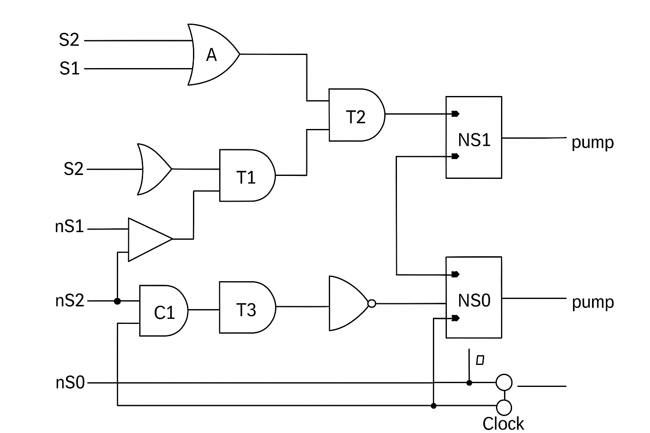

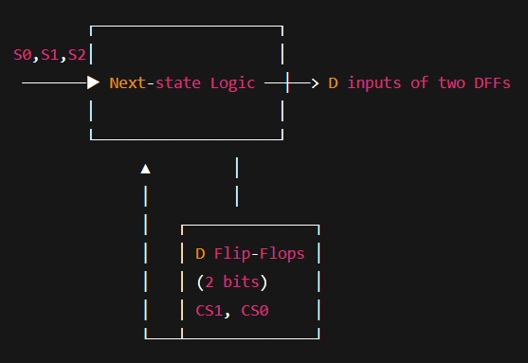

Flowchart of working:

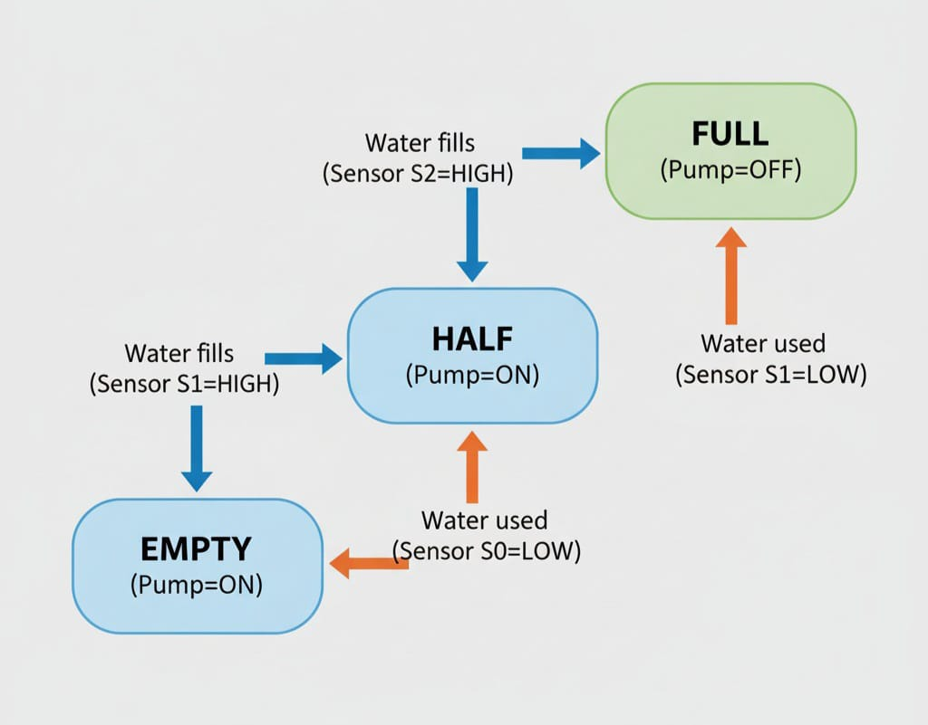

Working Diagram:
FILLING IN THE TANK
S2

S1

S0
S2

S1

S0

Stage 0 Stage 1
Sensors: S2=0 S1=0 S0=0 Sensors: S2=0 S1=0 S0=1
FSM state: EMPTY (00) FSM state: EMPTY(00)
Pump: ON (1) Pump: ON (1)
S2

S1

S0
S2

S1

S0

Stage 3 Stage 2
Sensors: S2=1 S1=1 S0=1 Sensors: S2-0 S1=1 S0=1
FSM state: HALF (01) -> FULL (10) FSM state: EMPTY (00) -HALF (01)
PUMP: OFF (0) PUMP: ON (1)

WATER CONSUMPTION
S2

S1

S0
S2

S1

S0

Stage 4 Stage 5
Sensors: S2=0 S1=1 S0=1 Sensors: S2=0 S1=0 S0=1
FSM state: FULL (10)-> HALF (01) FSM state: HALF (01) -> EMPTY(00)
PUMP: ON (1) PUMP: ON (1)
S2

S1

S0

Stage 6
Sensors: S2=0 S1=0 S0=0
FSM state: EMPTY (00) -> completely drain
PUMP: ON (1)

VERILOG IMPLEMENTATION

Verilog hardware file:
//====================================== // Smart Water Level Controller using FSM // Compatible with Icarus Verilog //======================================
module SmartWaterLevelController(
input clk,
input reset,
input S0, S1, S2, // Sensors
output reg pump // Pump control );
// State encoding (no typedef)
parameter EMPTY = 2'b00;
parameter HALF = 2'b01;
parameter FULL = 2'b10;
reg [1:0] current_state, next_state;
// Sequential block: state transition
always @(posedge clk or posedge reset) begin
if (reset)
current_state <= EMPTY;
else
current_state <= next_state;
end
// Combinational block: next state logic
always @(*) begin
case (current_state)
EMPTY: begin
if (S1 || S2)
next_state = HALF;
else
next_state = EMPTY;
end
HALF: begin
if (S2)
next_state = FULL;
else if (!S0)
next_state = EMPTY;
else
next_state = HALF;
end
FULL: begin
if (!S2)
next_state = HALF;
else
next_state = FULL;
end
default: next_state = EMPTY;
endcase
end
// Output logic (Moore type)
always @(*) begin
case (current_state)
EMPTY: pump = 1'b1; // Turn ON pump
HALF: pump = 1'b1; // Keep pump ON
FULL: pump = 1'b0; // Turn OFF pump
default: pump = 1'b0;
endcase
end
endmodule

Testbench:
//======================================
// Testbench for Smart Water Level Controller
// Compatible with Icarus Verilog
//======================================
`timescale 1ns/1ps
module tb_SmartWaterLevelController;

reg clk, reset;
reg S0, S1, S2;
wire pump;

// Instantiate DUT
SmartWaterLevelController dut (
.clk(clk),
.reset(reset),
.S0(S0), .S1(S1), .S2(S2),
.pump(pump)
);

// Clock generation
always #5 clk = ~clk; // 10ns clock period

initial begin
// Dumping setup for GTKWave
$dumpfile("SmartWaterLevel.vcd");
$dumpvars(0, tb_SmartWaterLevelController);

// Initialize
clk = 0;
reset = 1;
S0 = 0; S1 = 0; S2 = 0;
#10 reset = 0;

// Test sequence
#10 S0=0; S1=0; S2=0; // Empty
#20 S0=1; S1=0; S2=0; // Low
#20 S0=1; S1=1; S2=0; // Mid
#20 S0=1; S1=1; S2=1; // Full
#20 S0=1; S1=1; S2=0; // Dropping
#20 S0=1; S1=0; S2=0; // Lower
#20 S0=0; S1=0; S2=0; // Empty again

#20 $finish;
end

// Display states in numeric form
initial begin
$monitor("Time=%0t | S0=%b S1=%b S2=%b | State=%b | Pump=%b",
$time, S0, S1, S2, dut.current_state, pump);
end

endmodule

vvp output:
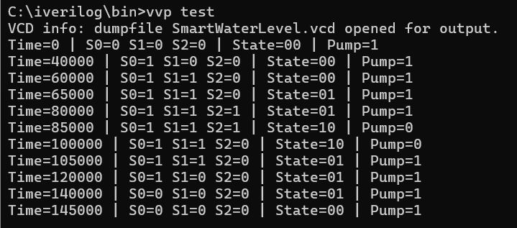

Gtkwave output:
